**Ionic App Creation**:

<http://ionicframework.com/getting-started>

<https://www.youtube.com/watch?v=O2WiI9QrS5s&feature=youtu.be>

**Requirements**:

1. Git (For windows)
2. Node.js
3. Visual Studio Code –(Terminal in Visual studio code can also be used instead of Git/command prompt)
4. Platform guides can be referred:

Android – <https://cordova.apache.org/docs/en/7.x/guide/platforms/android/>

IOS - <https://cordova.apache.org/docs/en/7.x/guide/platforms/ios/>

**Ionic Pro dashboard**:

1. Create an account (Kickstarter edition) using <https://dashboard.ionicjs.com/>
2. New app can be created in the dashboard and the steps listed out once a app is created can be followed. <https://ionicframework.com/docs/pro/basics/getting-started/>

Following steps can be followed to link an existing ionic app to ionic pro dashboard:

1. Move to the existing app dicrectory - cd myApp
2. npm install -g ionic@latest
3. ionic link

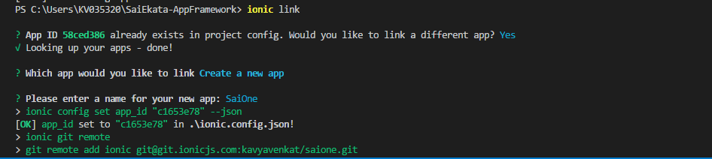

* 1. Update the changes to the local git repository(if any changes are made)
  2. git push ionic <branch-name>
  3. Also can set for auto-deploy from a specific branch.(Click on the channel name->Settings) 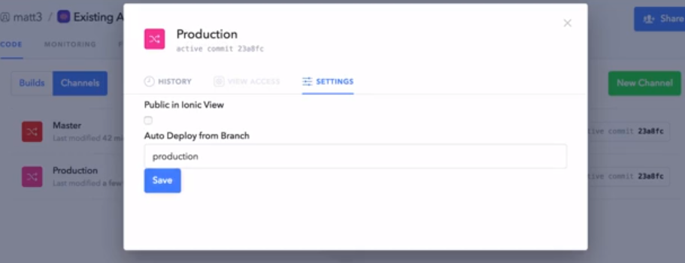

**Running an ionic app in browser**

ionic serve - -lab

Once an app is uploaded in the dashboard, we can deploy it to the playstore(android)/app store(ios)

**Set up Deploy**

1. To activate deploy for a channel,click on “Set up Deploy” adjacent to the channel.

Following modal pops up. I have chosen the highlighted one so that any new updates load on the splash screen of the app when the app is opened.

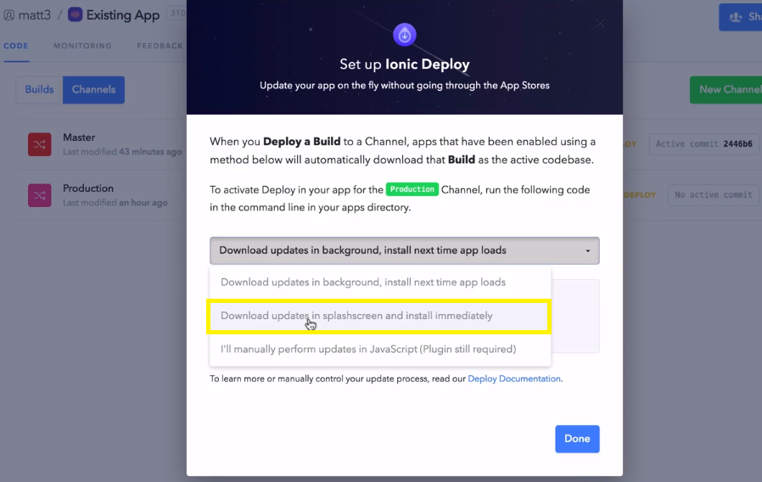

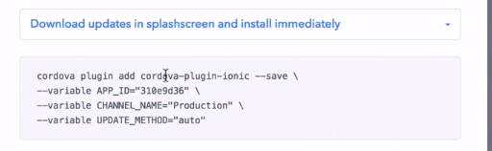

1. The above command should be run for installing the deploy plugin.
2. cordova platform add android / cordova platform add ios
3. I used the following command to generate a release build for android –

ionic cordova build --release android

1. For android, I built my final apk by following <https://developer.android.com/studio/publish/app-signing.html> (Build an unsigned APK and sign it manually) and uploaded it to playstore.
2. For IOS, refer to the tutorial in the following page - <https://ionicframework.com/docs/pro/deploy/setup/#installation>
3. Download and run the app.

**Performing Live updates**

1. Make Changes in any of the project files.(I had done a text change in one of the pages)
2. Ionic serve - -lab -> to check changes locally.
3. Normal Git updates
   1. git status
   2. git add -p
   3. git commit -m “some message”
   4. git push
4. git push ionic <branch-name>– to move the changes to ionic
5. Go to dashboard, wait till the build finishes. Check under the “Build” section if the latest build appears.
6. Select “Deploy” for the recent build and the choose the channel which you want the changes to be deployed.

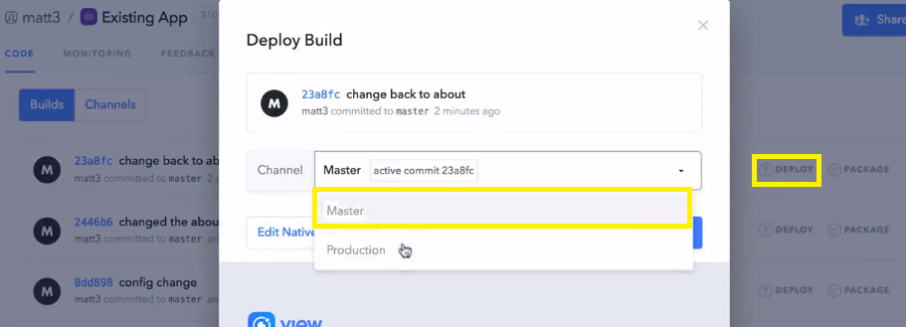

1. Click Deploy to deploy the new changes.

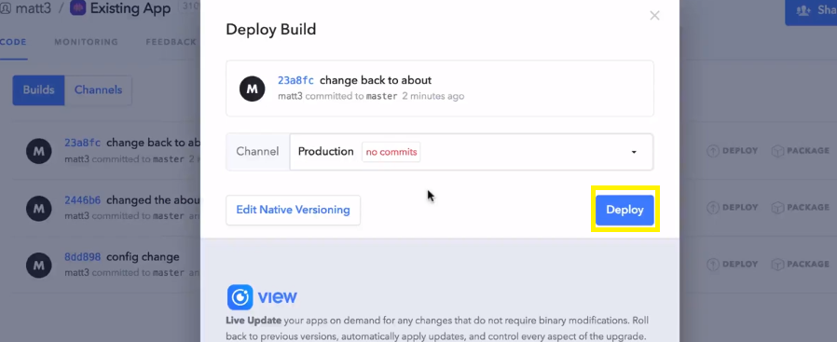

1. Wait till the process completes.
2. Open the app, the update loads in the splash screen and the new change will be reflected.

**Reference Links**:

1. <http://ionicframework.com/docs/v1/guide/publishing.html>
2. <https://nodejs.org/en/>
3. <https://dashboard.ionicjs.com>
4. <https://ionicframework.com/docs/pro/deploy/>